**7BUIS030W REVISION -1**

**Multiple Choice Questions**

1. The Data Protection Act is a law designed to protect what?
2. Your computer from being hacked
3. Personal data stored on computers
4. Theft of copyright materials
5. What is a person or company that collects data about people called?
6. Information commissioner
7. Data controller
8. Data subject
9. Which of the following is a tool to store, edit and organise data in a database?
10. A database
11. A database management system (DBMS)
12. SQL
13. What is a foreign key?
14. A foreign key is a field that is a unique identifier in that entity
15. A foreign key is a field that does not belong in that table
16. A foreign key is a primary key that appears in another table to create a relationship between the two tables
17. What is an entity?
18. A table in a database
19. A field in a database
20. A record in a database
21. What type of relationship exists between a person and national insurance number?

1. One to One
2. One to Many
3. Many to Many
4. Explain what is meant by DDL and DML with examples **[4 Marks]**
5. A company undertake projects in the IC design industry. Teams of engineers work on various chip design projects, under the guidance of their team leaders. These team leaders are frequently assessed during performance reviews to ensure that they are the right fit to lead the team. The company is seeking to design and develop a database-driven management system to be used internally to help organise the management and monitoring of projects.

The Conceptual Entity-Relationship Diagram (ERD) for part of the company management system is shown below (figure 1). Carefully consider this conceptual ERD.

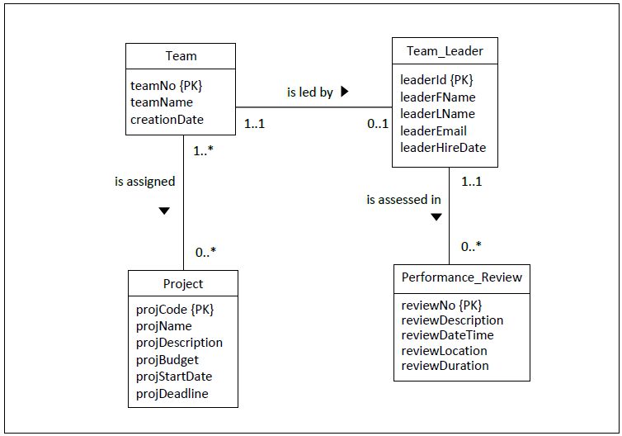

Figure 1: Conceptual ERD for part of the company management system

**Question 8.1**

1. Discuss in detail the multiplicity of the relationship ‘is led by’ (between the entities Team and Team_Leader). Provide adequate justifications to support your answers. **[4 Marks]**
2. Briefly explain how you would map the relationship *is led by’* (between the entities Team and Team_Leader) to a logical ERD. Provide a diagram to support your answer. Make sure you include all the correct attributes and keys. **[6 Marks]**

**Question 8.2**

1. Discuss in detail the multiplicity of the relationship ‘is assigned’ (between the entities Team and Project). Provide adequate justifications to support your answers. **[4 Marks]**
2. Briefly explain how you would map the relationship ‘*is assigned to work on’* (between the entities Team and Project) to a logical ERD. Provide a diagram to support your answer. Make sure you include all the correct attributes and keys. **[6 Marks]**

**Question 8.3**

1. Write a SQL query to display the complete names and email addresses of the team leaders who were hired after 7 January 2017 and whose surnames start with the letter R. **[5 Marks]**
2. Write a SQL query to display the Name, Description and budget of all the projects, but only for those projects that do not cost more than £250000.00 and less than £500000.00 **[5 Marks]**
3. Write the SQL Code to create the Team_Leader and performance_review tables for the MySQL RDBMS. Carefully think of the data type for every column, whether a column can be left empty or not and whether additional constraints need to be defined. **[10 Marks]**